“ALL PERSONNEL SHALL READ THE PLAN OF THE MONTH AND SHALL BE RESPONSIBLE FOR OBEYING ALL APPLICABLE ORDERS CONTAINED HEREIN. DIRECTIVES APPEARING HEREIN HAVE
THE FULL FORCE OF ORDERS ISSUED BY THE COMMANDING OFFICER.”

Commanding Officer | LT M. McFalls | (801) 201-0397 | co.151tmb@seacadets.org
Executive Officer (XO) | LCDR S. Bernier | (385) 249-6631 | xo.151uth@seacadets.org
Training Officer | ENS. R. Molina | (803) 989-0635 | robertfmolina00@gmail.com
Supply/Admin/PAO Officer | LTJG A. Benoit | (435) 820-4242 | so.151uth@seacadets.org
League Cadet OIC | INST. K. Mills | (385) 695-0076 | kristopher.mills0324@gmail.com

PLAN OF THE MONTH

For the Days of 27/28 JUN

Upcoming Drill Dates

JUL 10-18(Summer Training), 15-16 AUG

BE PROUD BE PROFESSIONAL
DATE | Muster | Release | Uniform of the Day  Cadets Officers
27 JUN 26 | 0745 | 1500 | PT/ Type III ALT’s/Type III or I
28 JUN 26 | 0745 | 1500 | PT/Type III ALT’s/Type III or I

Drill Notes

- Cadets MUST report in PT Gear.
- Cadets must bring lunch and hydration
- Cadets must have a full seabag including Dress WHITES Uniform
- Everyone Must Report Their Attendance In The Link Below
- https://forms.gle/oUdGH7rmGJ2m6KrV7
- Keep watching Quarterdeck for Summer Training’s to post.

NEW DRILL LOCATION
American Preparatory Academy
3636 W 3100 S, West Valley City, UT 84119

Commanding Officer Notes -

***Cadets with expired IDs are not eligible to participate in drill per NHQ regulations.*** If your cadet ID is expired you will not be allowed to participate and will be sent home. ID cards are produced at NHQ. They need 1 to 2 weeks to process. You can mail your dues (payment) into us before drill and we can have a new ID card for your cadet at our next drill. Contact me for the mailing address.

--Annual Renewal–

Per new instructions from National Headquarters, all cadets that are re-enrolling need to complete the new NSCADM001 form. This does require a new medical form that needs to be signed by a doctor. The new form will be e-mailed to cadets and parents when it is time to renew. Please complete the form and upload it to your parent portal. Submission your re-enrollment fee to the Admin Officer.

Annual dues are $175 per Cadet. Each additional sibling there is a discount. Please contact Admin for details.
Due can be paid by Cash; Check; or can be electronically paid on Venmo @Battleship_Utah
a. If paying by check, please make check payable to “BattleShip Utah”

*Per Sea Cadet regulations, cadets are not allowed to drill or participate in any activities if their membership expires.
The following matrix provides an overview of each cadet’s current status, including upcoming registration renewals dates, required Physical Readiness Test (PRT), required Polaris coursework, and what training they need for eligibility for advancement. Parents are encouraged to review this information carefully to ensure all requirements are completed in a timely manner, as these directly impact a cadet’s ability to promote and participate in training opportunities.
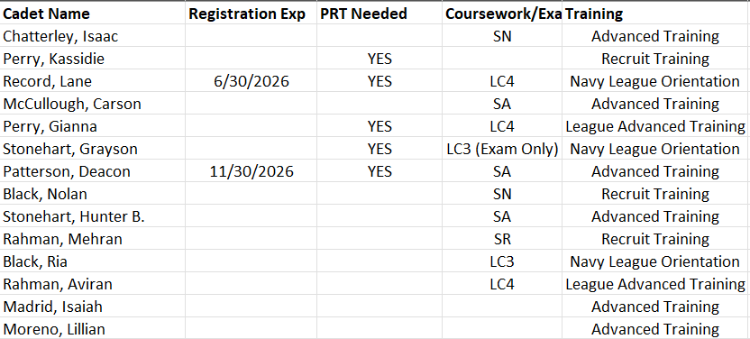

—Social Media—

Parents and Cadets that use Facebook please like and follow the unit Facebook page. This is a great communication tool, or come and visit our New website. Keep an eye out for our new quarterly newsletter.

Facebook
Battleship Utah Division BB-31 & Training Ship Bennion Sea Cadets

Website
https://utahseacadets.us/

